**To import the project…**

1. Import the .POM file from the BPDTS with API Framework>API>pom.xml
2. After the successful import, run mvn dependency:resolve
3. Packages will be downloaded, After that, run mvn clean install -DskipTests for compilation

**Framework explanation in short:-**

**XML File:**- For all the dependencies, plugins and Profiles. We are using Java, TestNG, RestAssured libraries and extent reports for this framework.

**src\main\resources\profile\api\config.properties :-** For the base URI. This file can be used for further parameters

**Environment.properties:-** This file will take the default profile set at the .POM file.

**src\test\java\com\BPDTS\test\framework\CommonMethods\APICommonMethods.java :-** This class will have all the common methods which will reduce the rework.

**src\test\java\com\BPDTS\test\framework\ENUMS\APIEndPoints.java**

:- This ENUM has a list of end points.

**src\test\java\com\BPDTS\test\framework\Helpers\GetResponse.java**

:- Helper folder will have all the helpers classes. Ex:- GetResponse.java, which will be used to get all the responses.

**src\test\java\com\BPDTS\test\framework\hooks\Screenshot\SetAPI.java**

:- hooks folder will have the all the classes which will contain the different hooks. Ex:- @Before, @After hooks where we can initialize the resources and in the @After hook, can have tear down / take screen shots functionalities

**src\test\java\com\BPDTS\test\StepDefinitions :-** This folder will have all the list of StepDefs methods which has a linkage to the feature file

**src\test\java\com\BPDTS\test\RunAPISuite.java :-** Runner class to run the feature files. We are using TestNG here (and at feature files for Assertions)

**Src\test\resources\features\api :-** All the feature filles will be residing in this folder

**API\target :-** This folder will have generated reports and resources. Ex:- check the “html” folder for the generated extent report

Run the scripts from the runner file to view the Extent report

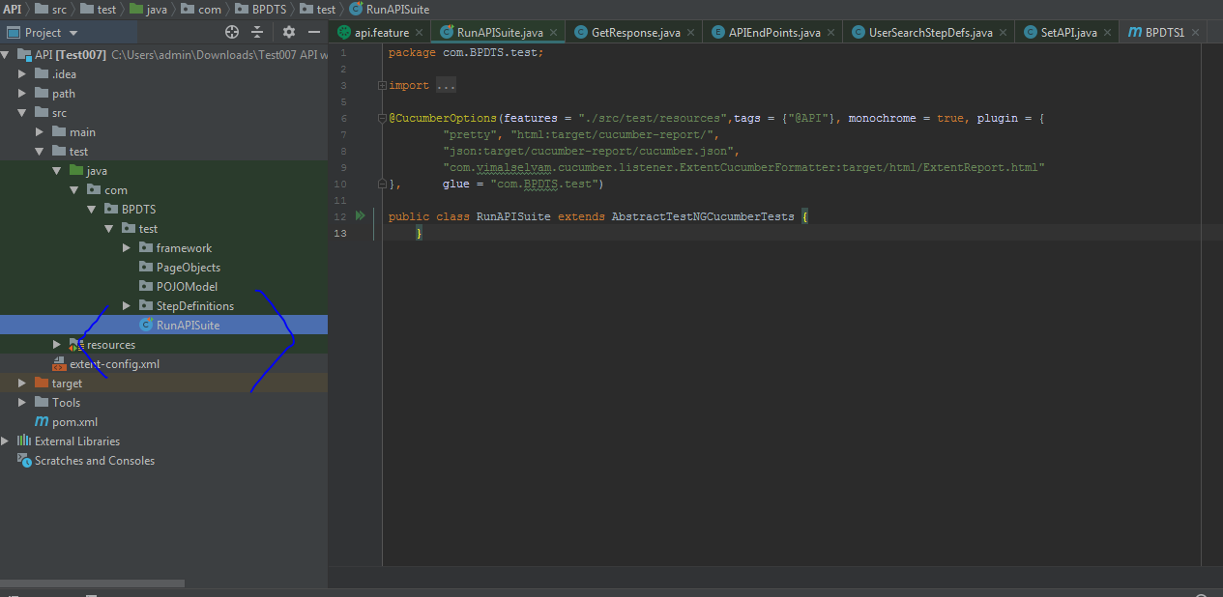

Extent Report Folder location

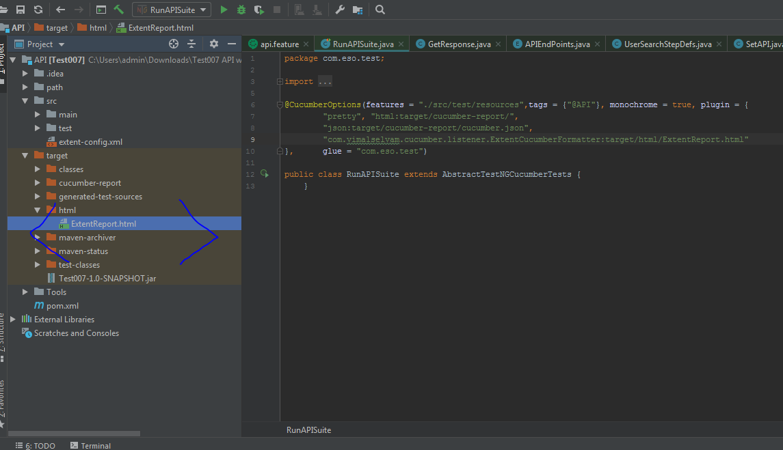

Open the extent report with the browser

